**Civics & Citizenship: Year 8 Source Analysis – Source Page**

**Source 1: Multicultural Australia**

Cover Image for the article “Australians awake to Glorious News that Massive Cultural Diversity Targets Within Government, Universities and Business”

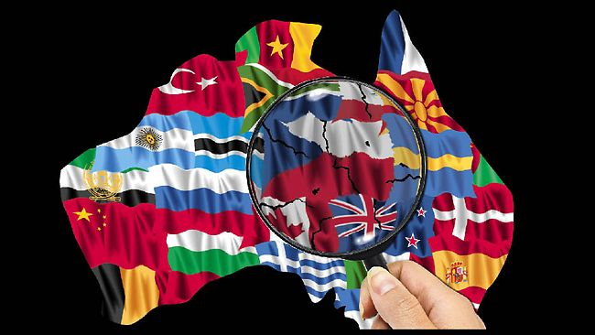Published by Steven A. in Diversity Australia on July 14, 2017.

**Source 2: *Australian Values***

*A ‘Tagxedo’ created by E.Gray that communicates some values and attitudes of the Australian Culture.*

*Published by AOS: Australian Identity (*[*https://gray24.weebly.com/culture.html*](https://gray24.weebly.com/culture.html)*) 2014*

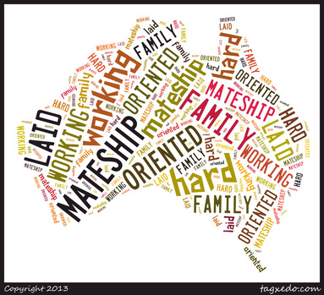

**Source 3:** ***Ned Kelly***

*Lyrics of the 1975 Iconic Australian Song: ‘Home Among the Gumtrees’.*

*Words and music published in 1975 by Mushroom Music pty ltd. On behalf of B. Brown and W. Johnson*

**Source 4:** ***Migration***

*The following diagram shows the population of Australia and Migration status (2013).*

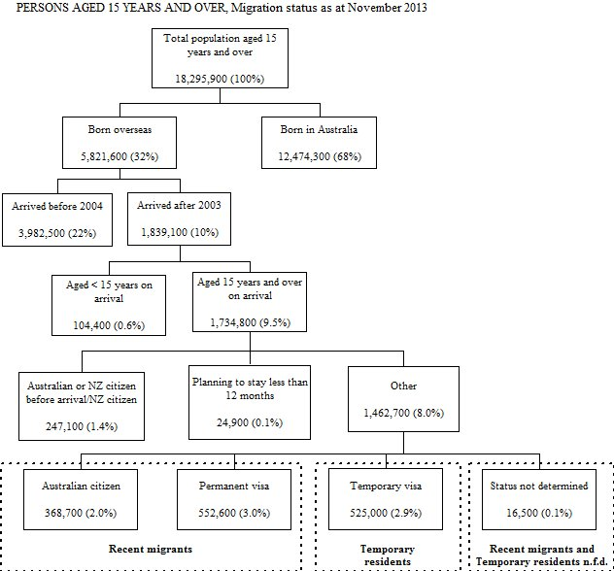

**Source 5:** ***Immigration***

*The following graph shows where people who immigrated to Australia were born (2011).*

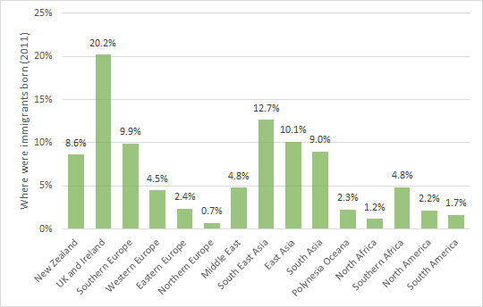

****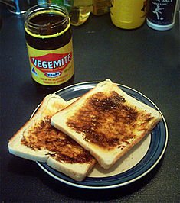****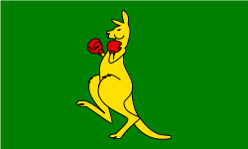****

**Source 10**

**Source 6**

**Source 8**

**Source 9**